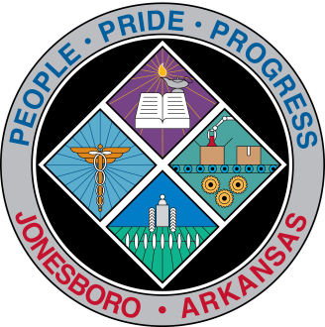
Communications Department
FOR IMMEDIATE RELEASE

July 18, 2018

Contact: Bill Campbell
Director of Communications
870-933-7164 (o), 870-919-7042 (c)
bcampbell@jonesboro.org

JET service opinions sought

The City of Jonesboro and the Northeast Arkansas Regional Transportation Planning Commission want to hear about residents’ experiences and suggestions regarding the JET bus service.

Take the Transit Survey to share comments on existing bus service to help the City understand needs and desires for public transportation in Jonesboro. Survey responses will help inform recommendations to improve the service.

Several events have been scheduled to speak with City and JET representatives:
- 5:30 p.m. Aug. 7: City Council chambers, Municipal Center, 300 S. Church St.;
- 3-7 p.m. Aug. 15: JET Regional Transfer Center, 713 S. Caraway Road;
- 6 a.m.-3 p.m. Aug. 16: JET Regional Transfer Center, 713 S. Caraway Road;
- 5-8 p.m. Aug. 16: Alive After Five event, 100 E. Huntington Ave.

###

